Chapter 3, Solution 54

Let the mesh currents be in mA. For mesh 1,
(1)
For mesh 2,
(2)
For mesh 3,
(3)
Putting (1) to (3) in matrix form leads to

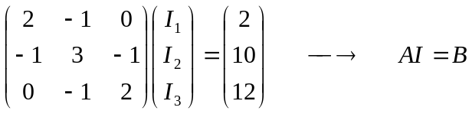
Using MATLAB,

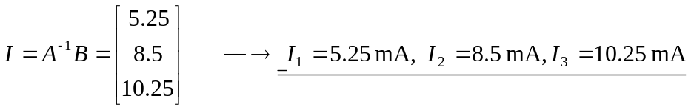

I₁ = 5.25 mA, I₂ = 8.5 mA, and I₃ = 10.25 mA.

